

**School of Computer Science and Artificial Intelligence**

Lab Assignment-10

**Program: B. Tech (CSE)**

**Specialization: AIML**

**Course Title: AI ASSITED CODING**

**Name of Student: V. Anognya Reddy**

**H. No: 2403A52244**

**Batch No: 09**



**Academic Session: 2025-2026** 

**Lab 10 – Code Review and Quality: Using AI to Improve Code  
Quality and Readability  
Lab Objectives**• Use AI for automated code review and quality enhancement.  
• Identify and fix syntax, logical, performance, and security issues in Python code.  
• Improve readability and maintainability through structured refactoring and comments.

• Apply prompt engineering for targeted improvements.  
• Evaluate AI-generated suggestions against PEP 8 standards and software engineering best practices

**Task Description #1 – Syntax and Logic Errors  
Task:** Use AI to identify and fix syntax and logic errors in a faulty Python script.  
**Sample Input Code:**# Calculate average score of a student  
def calc_average(marks):  
total = 0  
for m in marks:  
total += m  
average = total / len(marks)  
return avrage # Typo here  
marks = [85, 90, 78, 92]  
print("Average Score is ", calc_average(marks)  
**Expected Output:**• Corrected and runnable Python code with explanations of the fixes.

**Improved code:**

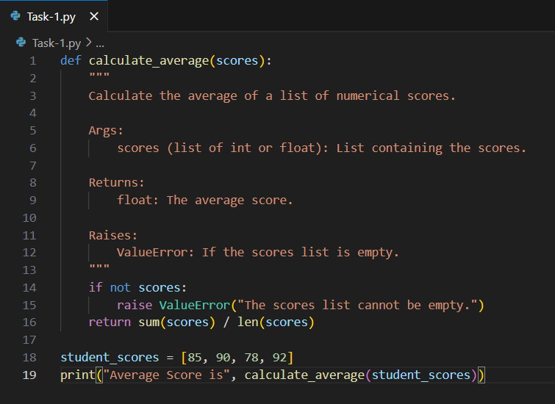

**Output:**

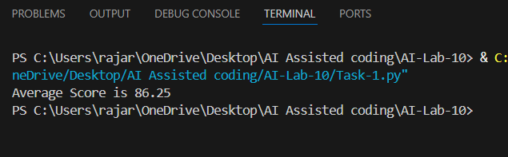

**Task Description #2 – PEP 8 Compliance  
Task:** Use AI to refactor Python code to follow PEP 8 style guidelines.  
**Sample Input Code:**  
def area_of_rect(L,B):return L*B  
print(area_of_rect(10,20))  
**Expected Output:**• Well-formatted PEP 8-compliant Python code.

**Improved Code:**

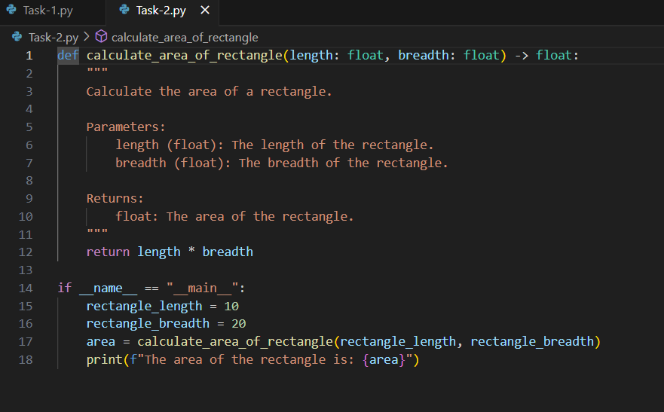

**Output:**

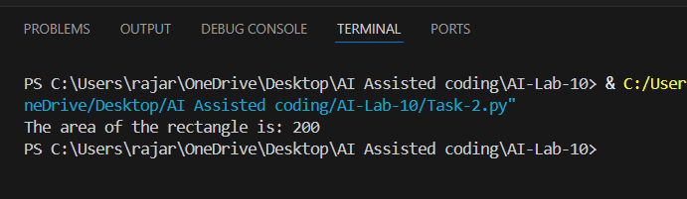

**Task Description #3 – Readability Enhancement  
Task:** Use AI to make code more readable without changing its logic.  
**Sample Input Code:**  
def c(x,y):  
return x*y/100  
a=200  
b=15  
print(c(a,b))  
**Expected Output:**• Python code with descriptive variable names, inline comments, and clear formatting.

**Improved Code:**

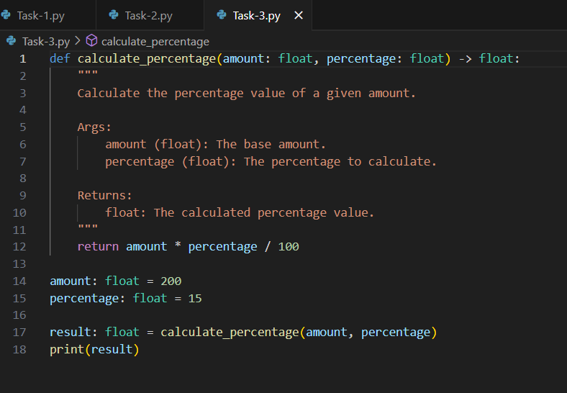

**Output:**

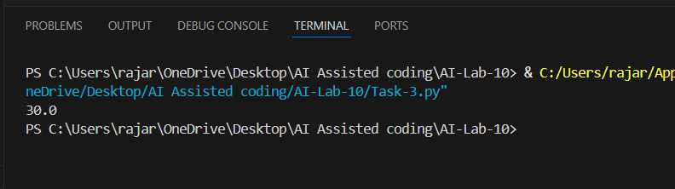

**Task Description #4 – Refactoring for Maintainability  
Task:** Use AI to break repetitive or long code into reusable functions.  
**Sample Input Code:**  
students = ["Alice", "Bob", "Charlie"]  
print("Welcome", students[0])  
print("Welcome", students[1])  
print("Welcome", students[2])  
**Expected Output:**  
• Modular code with reusable functions.

**Improved Code:**

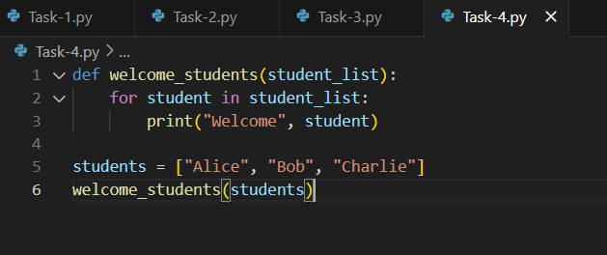

**Output:**

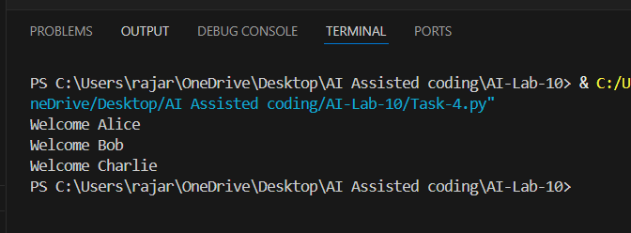

**Task Description #5 – Performance Optimization  
Task:** Use AI to make the code run faster.  
Sample Input Code:  
# Find squares of numbers  
nums = [i for i in range(1,1000000)]  
squares = []  
for n in nums:  
squares.append(n**2)  
print(len(squares))  
**Expected Output:**• Optimized code using list comprehensions or vectorized  
operations.

**Improved code:**

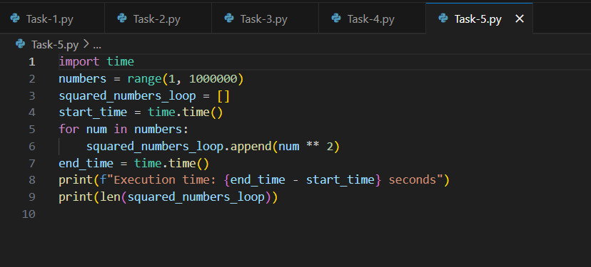

**Output:**

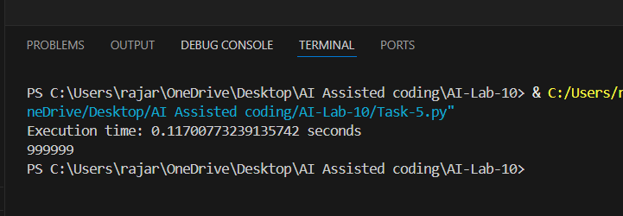

**Task Description #6 – Complexity Reduction  
Task:** Use AI to simplify overly complex logic.  
**Sample Input Code:**def grade(score):  
if score >= 90:  
return "A"  
else:  
if score >= 80:  
return "B"

else:  
if score >= 70:  
return "C"  
else:  
if score >= 60:  
return "D"  
else:  
return "F"  
**Expected Output:**• Cleaner logic using elif or dictionary mapping

**Improved code:**

